**Software Resource Specification**

**Version 1.0 Approved**

**Prepared By:**

Rohan Mendiratta

**Date:** 18/09/2016

**Table of Contents**

**Table of Contents 2**

**Revision History 2**

1. **Introduction 3**

1.1. Purpose 3

1.2. Document Conventions 3

1.3. Intended Audience and Reading Suggestions 3

1.4. Scope 3

1.5. Reference 4

**2. Overall Description 4**

2.1. Product Perspective 4

2.2. Product Functions 4

2.3. User Classes and Characteristics 5

2.4. Operating Environment 5

2.5. Design and Implementation Constraints 6

2.6. Assumptions 6

**3. External Interface Requirements 6**

3.1. User Interfaces 6

3.2. Hardware Interfaces 6

3.3. Software Interfaces 6

3.4. Communication Interfaces 6

**4. System Features 7**

4.1 System Feature 1 7

4.2 System Feature 2 7

4.3 System Feature 3 8

4.4 System Feature 4 8

**5. Other Nonfunctional Requirements 8**

5.1 Performance Requirements 8

5.2 Safety Requirements 9

5.3 Security Requirements 9

5.4 Availability and Maintainability 9

5.5 Business Rules 9

**Appendix A: Glossary 10**

**Appendix B: Analysis Models 10**

**Appendix C: To be determined list 10**

**Revision History**

|  |  |  |  |
| --- | --- | --- | --- |
| **Name** | **Date** | **Reason for Changes** | **Version** |
|  |  |  |  |
|  |  |  |  |

1. **Introduction**

**1.1 Purpose**

This is an SRS for an Enterprise Resource Planning System for an Apparel Manufacturer and Exporter. The report below is an overview of the features, hardware and software requirements, and other such basic needs of the system. The ERP system that will be made has a limited scope as it caters to the company’s demands only.

**1.2 Document Conventions**

SRS - Software Resource Specification

UI - User Interface

ERP - Enterprise Resource Planning

**1.3 Intended Audience and Reading Suggestions**

Keeping in mind the huge fashion industry in today’s generation, this document has been written to cater to readers from various backgrounds. The developers can read it so that they can understand the back end and what went behind the development. The Marketing Staff will be able to identify the key areas they can focus on to generate maximum profits. The general users will be able to find out how the ERP system is helping the garment company as well as clothing industry in general.

**1.4 Scope**

As mentioned in the Purpose, the ERP system covers the requirements of the garment manufacturing and exporting company, and provides a backbone system for them to work on. Hence, the scope of the system is limited to the company, because of the very specific needs that the company may have.

**1.5 Reference**

Wikipedia and basic definitions.

**2. Overall Description**

**2.1 Product Perspective**

The final product is a brand new product built from scratch, revised to cater to specific requirements of the manufacturer. It will be integrating various modules which would be picked from various open sources. The customized ERP system will support the manufacturing and exporting business model and will help make the company’s working more regulated and structured.

**2.2 Product Functions**

* Login into accounts
* Complete Inventory & Accounts
* Sales and Dispatch
* Invoice Records for Purchase and Ordering
* Taxes
* Production
* Inventory Reports
* Employee Records & Wages

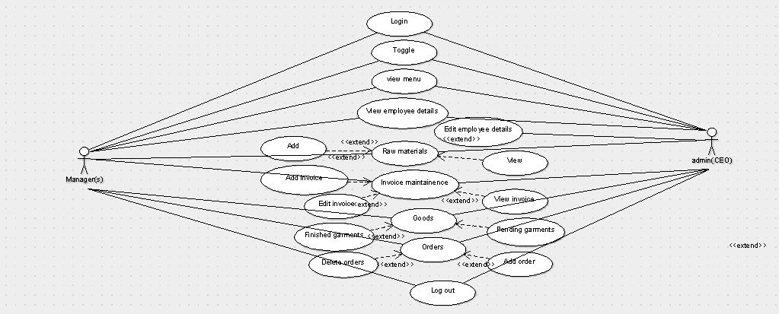

**2.3 User Classes and Characteristics**

The ERP System will have 3 levels of access,

1. The Salespeople, and other low-level staff.
2. The Managers
3. The Heads of Various Departments

* The Salespeople and low-level staff will be able to access the Inventory, Sales and Purchase modules.
* The Managers would be able to access the Inventory, Sales, Purchase, Ordering, Taxes and Employee Records & Wages modules.
* The Heads of Departments would be able to access the Inventory, Sales, Purchase, Ordering, Taxes, Production, Inventory Reports and Employee Records & Wages, ie all the modules of the ERP.

**2.4 Operating Environment**

The ERP is going to be web-based, and hence anyone can access it on his/her laptops/smartphones/tablets and other similar devices. The support and accessibility may vary depending on your browser/device version.

**2.5 Design and Implementation Constraints**

We will be using basic MySQL and other similar languages. Bits of other third party apps may be used to support the system.

**2.6 Assumptions**

* The inventory details are accurate.
* The requirements of the company are to the point and cover everything.
* There is internet availability at the outlets.

**3. External Interface Requirements**

**3.1 User Interfaces**

The interface will be a smooth, lightweight system, which would be easy on the eyes of the users. The interface would be very simple to use, with a sleek design, so that the users can do what is required without getting stuck with the complexities.

**3.2 Hardware Interfaces**

The ERP would be a fully web based product, and hence the device should be fully capable of running a modern web browser. The display should have a decent size, so that it can display everything clearly for the user.

**3.3 Software Interfaces**

MySQL/other similar language will be used for front end development. Other software interfaces have not been finalised yet.

**3.4 Communication Interfaces**

The system would notify users via Email when the products are out of stock in the inventory. The wages of the employees would be communicated to them via Email, and SMS. The production of the stock and the service requirement would be notified via communication to the user.

**System Features**

**4.1 Account Login**

**4.1.1 Description and Priority**

All the users of the ERP would be required to login to the their accounts using this feature. This ensures that the right person is accessing the information. Without logging in, the user would not be able to access any confidential data.

This is a high priority feature.

**4.1.2 Stimulus/Response Sequences**

The user will enter a pre-decided username and password. Only on entering the corrects login credentials will the user be allowed access.

**4.1.3 Functional Requirements**

For this feature, the system will support taking written input from users. The correct login credentials must be registered into the system beforehand by the admin or the person in-charge of similar responsibilities.

**4.2 Complaint Form**

**4.2.1 Description and Priority**

Any complaints by the users, managers, salespeople, and heads will be logged into this section so that they can be looked upon with ease, and worked upon as soon as possible.

This is a high priority feature.

**4.2.2 Stimulus/Response Sequences**

The user will enter a query or a complaint that he may have. An email will be sent to the user and the person responsible for handling the complaints to confirm that the complaint has been registered.

**4.2.3 Functional Requirements**

For this feature, the system will support taking written inputs from users. The communication interface detailed above would come in handy here.

**4.3 Upcoming Wages**

**4.3.1 Description and Priority**

The heads and managers would be able to see this to get notified of the employee’s wages. Once again, this is a high priority feature.

**4.3.2 Stimulus/Response Sequences**

The system would be storing the employee details including the wages. 3 days before the date of the wage payment day, the ERP will make sure the person in charge is notified.

**4.3.3 Functional Requirements**

For this feature, the system will support basic communication interfaces. Along with the capability of storing and processing employee payment dates and time.

**4.4 Products Running Low On Stock**

**4.4.1 Description and Priority**

All the users, ie, the salespeople, managers and heads will be able to see this to get notified of the product’s stock. When the product is running out of stock, this will make sure that new products are brought in.

This is a medium priority feature.

**4.4.2 Stimulus/Response Sequences**

The ERP will be having all the inventory details stored and updated. When a product has less than 3 pieces remaining, the ERP will notify the person responsible.

**4.4.3 Functional Requirements**

For this feature, the system will be supporting the capability of storing and processing product details and quantity. The basic communication interfaces would be used to notify the person in-charge.

**5 Other Nonfunctional Requirements**

**5.1 Performance Requirements**

Since the ERP is completely web-based, it needs to be quickly accessible and smooth to run. It should allow the users to access the various information with ease, and should display everything in a clear and concise manner. The separate features mentioned above should run well with the ERP and should be integrated in a seamless fashion.

**5.2 Safety Requirements**

The data should be backed up, in case, any unfortunate incident happens and the critical data gets wiped out.

The data might get infected by some malware or adware on the internet, and hence specific security measures should be taken.

**5.3 Security Requirements**

The data in the ERP must be encrypted to the general users as it contains data which is critical to the operation of the company. Each level of access should be accessible to the correct person only, so that the company hierarchy remains intact and in place along with the product information.

The users will be registering to the ERP system, and their login credentials have to remain encrypted, so that no other member can access their information. The employee wage must remain confidential and should not be accessible to other members of the same access level, while being accessible to the managers so that they can monitor the wages.

**5.4 Availability and Maintainability**

The ERP must be easily available to all the users with internet and internet browser (supported). It should be available on a wide variety of devices so that people can access it while on the go, and get any urgent work done with ease.

The servers hosting the ERP should be well maintained and working round the clock to ensure flawless functioning of the system.

The ERP should be regularly updated to stay relevant in the ever-changing world of technology. It should be regularly troubleshooted to answer all the complaints and queries of the users. The maintenance should be done to fix the bugs that may arise, to keep the backbone software behind the operation of the company flawless.

**5.5 Business Rules**

There should be a troubleshooting team in place to handle the working of ERP.

A team should be in place to make sure all the complaints and queries are taken care of.

The notifications that the ERP will send will be automated.

The products manufactured will be updated by the person in-charge only, and should not be handled by anyone else.

**Appendix C: To Be Determined List**

* Queries sorted by username.
* Employee Wage Sorted by Amount.
* Product Stock sorted by quantity.
* Notifications sorted by time.